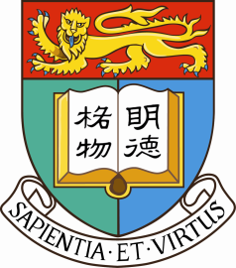 |  | Centre for Chinese Law  Faculty of Law, The University of Hong Kong  香港大學法律學院中國法研究中心
Rule of Law
After the Fourth Plenary Session of the 18th Communist Party of China (CPC) Central Committee?
四中全會之後的依法治國？
Time: 9:30am-1:00pm
January 3 Saturday 2015
Venue: Academic Conference Room, 11/F, Cheng Yu Tung Tower, HKU
*The speakers will speak in Putonghua, Cantonese or English. 講者將以普通話、廣東話或英語發言。
Session One 9:30am-11:15am
Session One Chair Person
Professor Fu Hualing, Faculty of Law of The University of Hong Kong
- Rule of Law and Constitutional Review
Professor Lin Feng
Associate Dean, School of Law, City University of Hong Kong
- How to Speed up the Construction of a Law-based Government
Professor Zhu Xinli
Executive Dean, Zhejiang University Law School
- Judicial Reform in China in the Next Ten Years
Professor Xu Xin
School of Law, Beijing Institute of Technology

第一節 主持
傅華伶教授 香港大學法律學院
依法治国与违宪审查
林峰教授
香港城市大學法律學院教授、副院長
如何加快建設法治政府
朱新力教授
浙江大學法學院教授、常務副院長
未來十年中國的司法改革
徐昕教授
北京理工大學法學院

Session Two 11:30am-1:00pm
第二節 主持
陳弘毅教授 香港大學法律學院
如何落實和深化“依法治國”
劉銳紹先生
時事評論員
四中全會對香港的意義
Susan Finder 女士
“最高人民法院觀察” 博客

Session Two Chair Person
Professor Albert Chen, Faculty of Law of The University of Hong Kong
- How to Implement and Further the Rule of Law in China
Mr Johnny Yui-sui Lau
Political Commentator
- What the 4th Plenum Means for Hong Kong
Ms Susan Finder
Blogger, Supreme People's Court Monitor

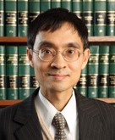
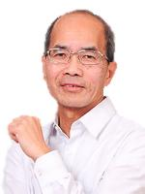
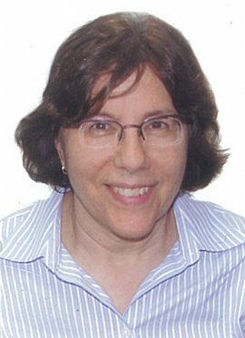
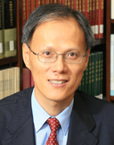
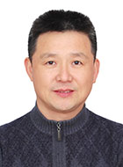
Admission Free; Registration Required at www.law.hku.hk (Seminars & Conferences)
All Are Welcome; Enquiries: Ms. Tina Xie (tinaxie@hku.hk)

